Chapter 17, Problem 16.

The waveform in Fig. 17.55(a) has the following Fourier series:

Obtain the Fourier series of v₂(t) in Fig. 17.55(b).

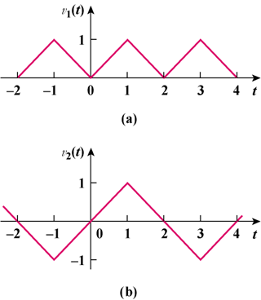

Figure 17.55
For Prob. 17.16.

